

**COMPUTER ENGINEERING**

**DS ODD SEM 2021-22/EXPERIMENT 4 NAME:- GAURAV AMARNANI (D7A, 67)**

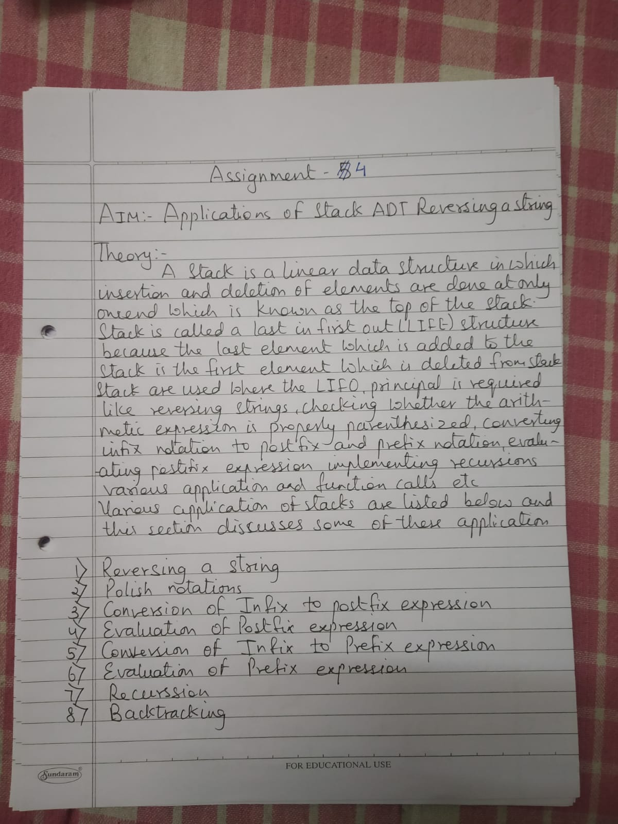

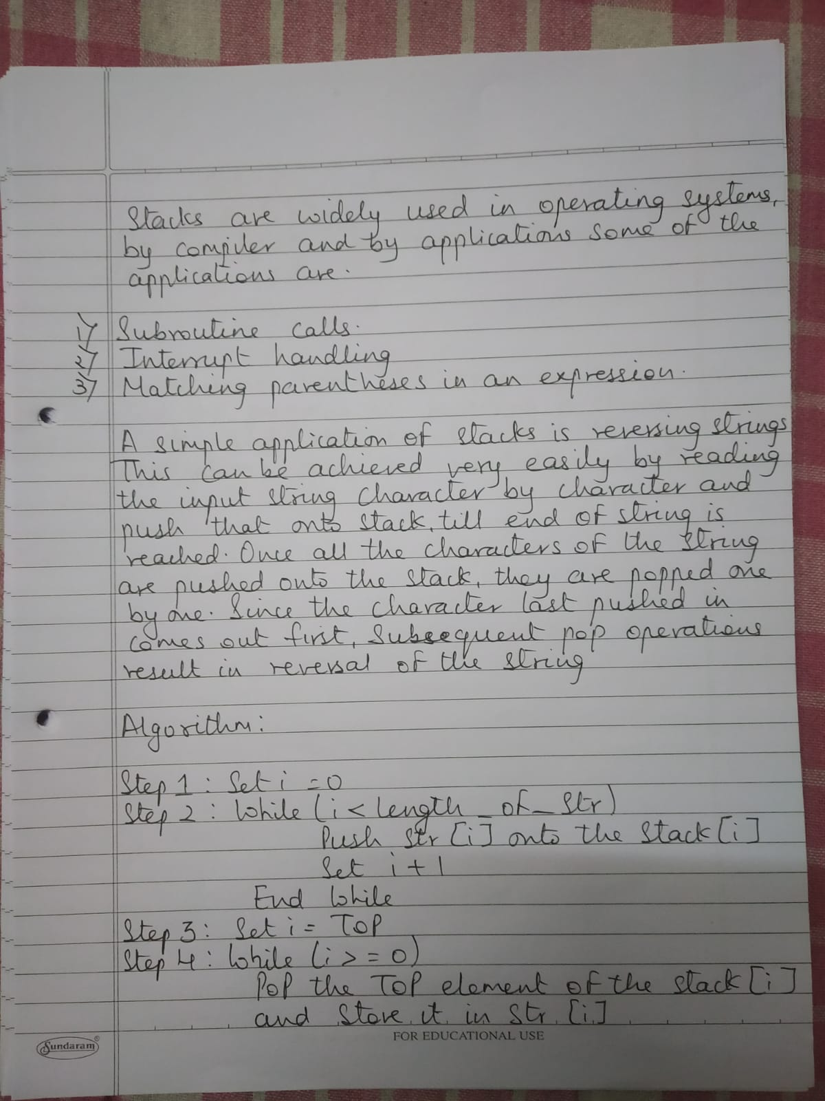

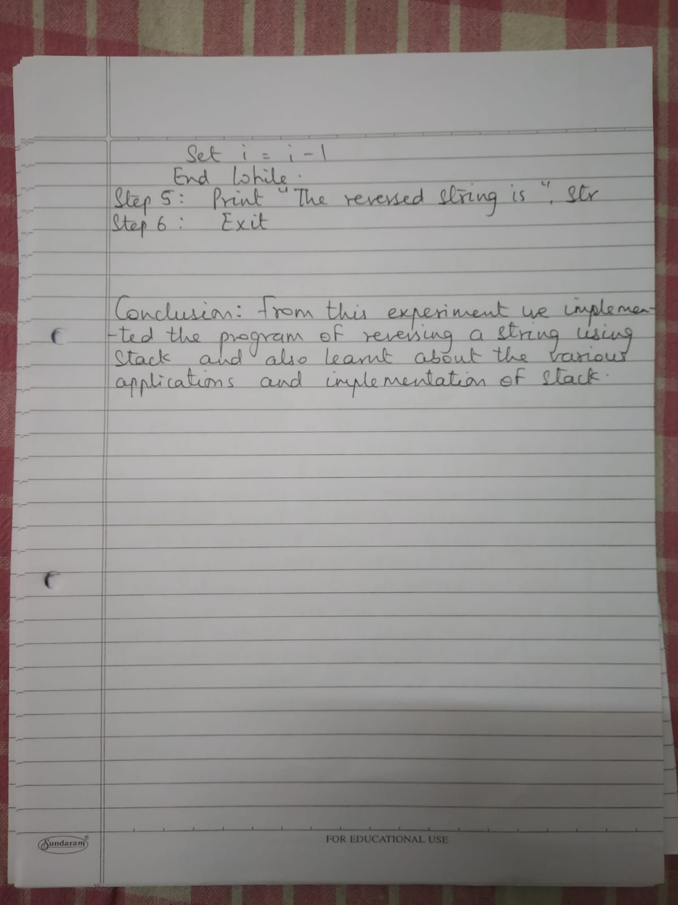

**PROGRAM:**

#include <stdio.h>

#include <string.h>

#define max 100

int top,stack[max];

void push(char x){

if(top == max-1){

printf("stack overflow");

}

else {

}

stack[++top]=x;

}

void pop(){

printf("%c",stack[top--]);

}

void main() {

char str[]="KESAR";

int len = strlen(str);

int i;

clrscr();

printf("String before reversing : %s\n", &str);

for(i=0;i<len;i++)

push(str[i]);

printf("String after reversing : ");

for(i=0;i<len;i++)

pop();

getch();

}

OUTPUT:-

